File Permissions:

* Provide extra security layer
* Whenever a website is no longer in development and is available to the public:
* Be vigilant(cautious) about exposing your site to hacking
* Create a separate directory for uploaded files
* Develop permissions to give you an extra layer of defense
* Grant as few permissions as it takes to get the job done
* Windows File Permissions
* Easier
* Can be managed through Properties/Security tab
* Default permissions may work
* Security model is simpler
* Harder
* Windows versions differ
* Many PHP methods are ignored
* Basically three types of users are available in MAC OS X, UNIX, LINUX
* User – which is us. The person who created the file or owner of the file.
* Group – a group of users. We assign people to groups
* Other (World) – which is everybody. Public and large it not just us or groups it just others.

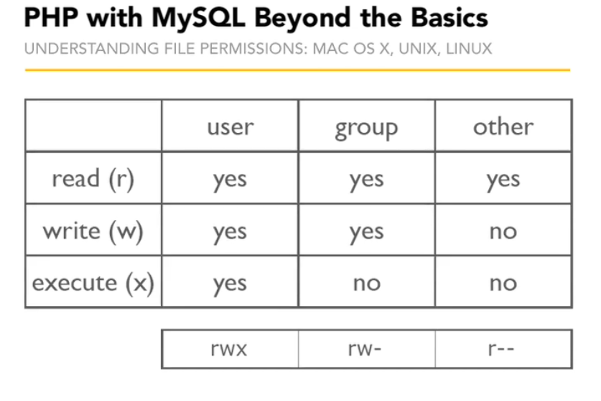

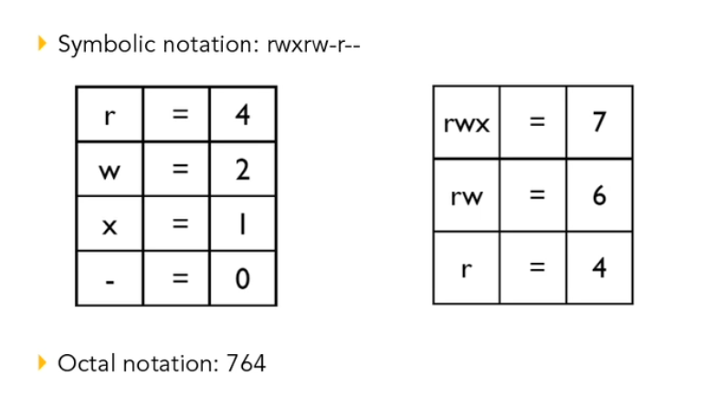

* Here 764 is equivalent to rwxrw-r--

File Permissions:

* Execute – Can run a file as well.

Linux Command

* ls for listing files
* ls –la shown all files with information

Setting File Permissions

* Chown – change the ownership
* Chmod – change the permission
* Sudo – do the command with the highest level permissions that the system has.
* Do as su(super user)
* Do the command with the highest level of security.
* Know which user apache running is (Know Web Server)
* Ps aux | grep httpd
* Change ownership
* Sudo chown www(owner name) file_permissions.php
* Change file permissions
* Sudo chmod 777 file_permissions.php
* Directory Write read write and executable
* sudo chmod 777 .

PHP and File Permissions

* Safe mode
* If safe mode is on php checks to the owner of the current php script running; matches the owner of the file then manipulate the file; so in safe mode we don’t have the ability to manipulate the file if file is not own. This feature is mainly for share hosting environment. It don’t strictly follow certainly follow in development or developer environment.

Accessing Files

* Fopen(filename, mode)
* Either open a file or ability to create new one.
* File Access Modes
* R – Read from start (must exist)
* W – Truncate/Write from start
* A – Append/write from end
* X – Write from start (can’t exist)

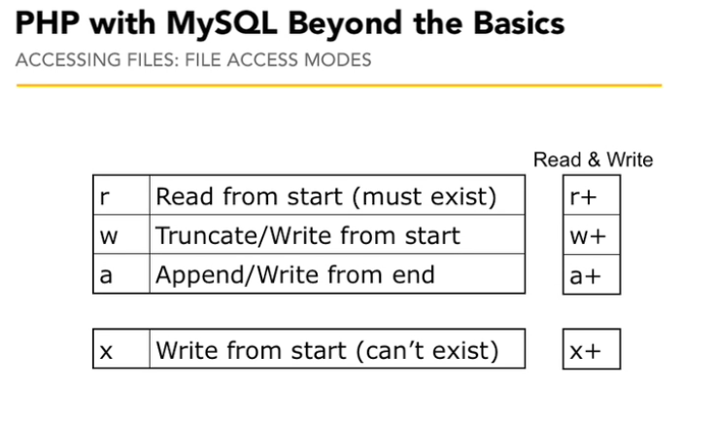

* File line endings
* Windows \r\n
* Mac, Linux, Unix \n
* File mode modifiers
* T – Translate windows line endings (use \r\n)
* B – Binary mode (don’t translate)
* B is the default on all platforms since PHP 4.3.2

Handle

* A file handle is simply a Resource pointing to a file that you have opened. You may have more than one file handle pointing to one file at the same time, and each might be in a different mode - unexpected behavior might result, however, and there is generally no reason for this.

Deleting Files:

* Close files first
* Can’t delete open files
* Must have permission on folder containing the file

Configuring PHP for Email

* Php.ini Mail Settings
* SMTP
* Smtp_port
* Sendmail_from
* Sendmail_path
* Sendmail
* Sending Email
* Mail($to, $subject, $message, $headers);

SMTP Overview

* Simple Mail Transfer Protocol
* Essential SMTP Info
* Server/Host
* Port
* Authentication
* Username
* Password

Windows users can use PowerShell for command line actions:

<http://www.myitforum.com/myITWiki/WinPowerShell.ashx>

Configuring PHP for file uploads

* php.ini uploading checklist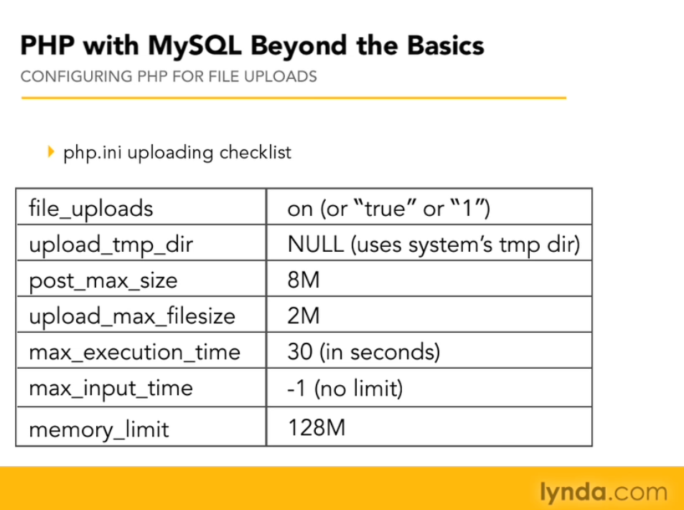
* Files will be found in the $_FILES superglobal variable not in the $_POST variable.

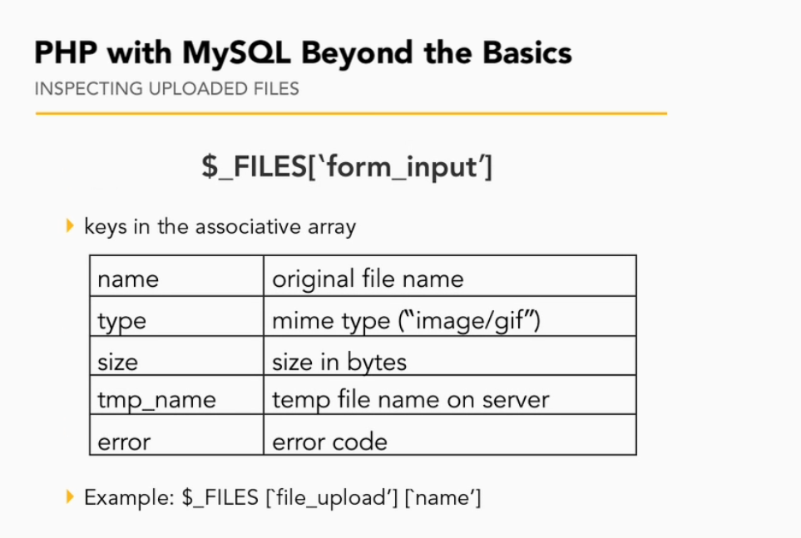

File Uploads Error:

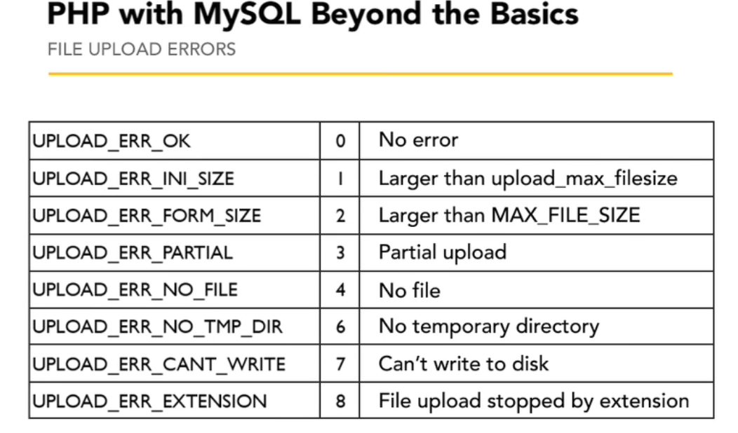

Basename: The basename() function returns the filename from a path.

Join()

* The join() function returns a string from the elements of an array.
* The join() function is an alias of the implode() function.
* The separator parameter of join() is optional. However, it is recommended to always use two parameters for backwards compatibility.

Redirect:

* Redirection actually new request
* New request comes to the browser
* New set of headers come to the browser
* Telling the browser hey page comes to the browser
* Starting the whole cycle over new-request response cycle
* Previous will remove

Resource

* A resource is a special variable, holding a reference to an external resource. Resources are created and used by special functions.

This

* $this reference current instance.

Log Directory:

Log File: In log file we can write errors or something else in this project we write login history in log file.

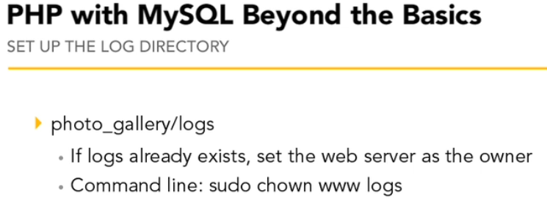

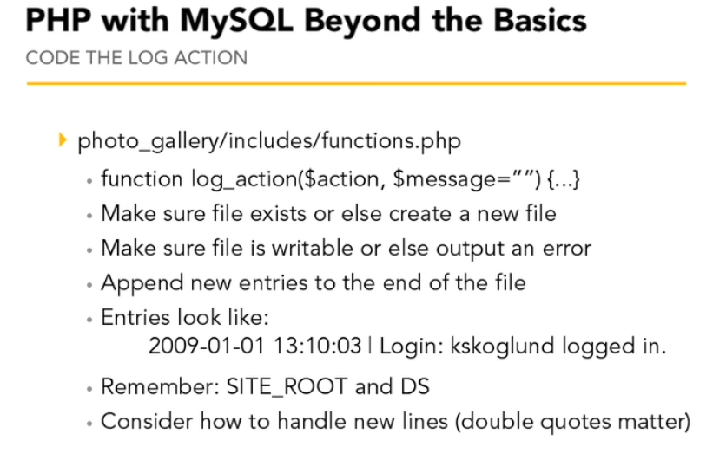

* Use log_action() in photo_gallery/public/admin/login.php

